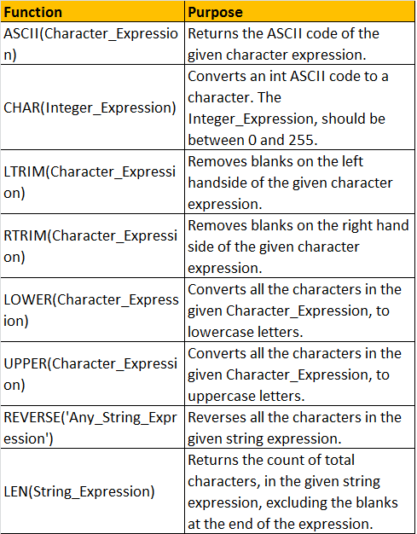

|  |  |  |
| --- | --- | --- |
| **Function** | **Date Time Format** | **Description** |
| GETDATE() | 2012-08-31 20:15:04.543 | Commonly used function |
| CURRENT_TIMESTAMP | 2012-08-31 20:15:04.543 | ANSI SQL equivalent to GETDATE |
| SYSDATETIME() | 2012-08-31 20:15:04.5380028 | More fractional seconds precision |
| SYSDATETIMEOFFSET() | 2012-08-31 20:15:04.5380028 + 01:00 | More fractional seconds precision + Time zone offset |
| GETUTCDATE() | 2012-08-31 19:15:04.543 | UTC Date and Time |
| SYSUTCDATETIME() | 2012-08-31 19:15:04.5380028 | UTC Date and Time, with More fractional seconds precision |

**Note**: **UTC**stands for **Coordinated Universal Time**, based on which, the world regulates clocks and time. There are slight differences between GMT and UTC, but for most common purposes, UTC is synonymous with GMT.

**The following table lists a few of the common DateTime styles:**  
